

Trackable bulk mail solution

Additional feature
Table of Contents
Table of Contents 1
Document Revision History 3
Introduction 4
Purpose 4
Scope 4
User Rights 5
Overall Description 6
Product perspective 6
User Characteristics 6
Functional Requirements For Web Portal 7
Sent Campaign View and Resend option: 7
Ipv6 Support: 10
Domain Based ROUTING (THird Party Api): 11
Exclude Group: 14
Group Creation under Reporting section: 15
Removal of duplicate mails: 16
Suppressed Mail reporting: 17
From Name Personalization: 18
Template Upload option: 19
Suppression list scrubbing: 20
Suppression list Copying: 21
Account lock out Policy: 21
IMPLEMENT CAPTCHA For Login page: 22
Display user's last login details 23
Personalization of Subject lines: 24
Display campaign Id for campaign: 24
Unsubscribe Link To BE optional: 25
Link Personalization: 25
List Management (Add/edit in contact list) 26
Maker & Checker (Moderation process) 28
Promotional Campaign via FTP/SFTP 34
Unsubscription through Email: 36
Import/export data through csv: 38
Preview Mail: 40
link & image validator: 40
Support of Forget Password 41
New options in Admin Setting 43
suppression list : 44

Document Revision History

Document Version | Date | Page No | Author
SRS V1.0 | 14th July 2015 |  | Vaishali Kataria

Introduction
This section gives a scope description and overview of everything included in this SRS document. Also, the purpose for this document is described and a list of abbreviations and definitions is provided.

Purpose
The purpose of this document is to give a detailed description of the requirements for the “Trackable Bulk Mail Solution”. It will illustrate the purpose and complete declaration for the new features development of system. It will also explain system constraints, interface and interactions with other external applications. This document is primarily intended to be proposed to the customer for its approval and a reference for developing the first version of the system for the development team.

Scope
Trackable Bulk Mail Solution (TBMS ) is a platform that will facilitate users to send bulk emails. They can upload their csv file of contact emails to which they want to send emails and can send this through the system. They need not to draft same mail again and again and need not to send separately. They can just draft message for one time and can upload csv file for once. In this csv file they will add email addresses to which they want to send emails. This application is very useful for commercials, ad agencies, event companies etc. SO they can send their offers, advertisements to their customers in bulk.
There are many other similar products available in market but still this product have some specific features like complete tracking of emails including their delivery status, skipped status, action status. With these status they can track individual one like how many delivered, how many bounced, how many undelivered, how many excluded, how many suppressed, how many duplicate emails. So this system tracks complete statistic & actions performed by individual user along with their specific email.
To make this system more efficient we have developed some new features. So now this system have lot of features that can easily compete with other available similar products.

User Rights
Table 1 – Rights
User Type | Compose | Setting | Reports
Admin | OK | OK | OK
Domain Admin | OK | [Add only SimpleUser, View only Domain Setting] | [Can View Report only his Domain]
Report Admin | NO | NO | Can View All Domain's Report [Address Book, Schedule not available]
Report Domain | NO | NO | Can View his Domain's Report only [AddressBook, Schedule not available]
Simple User | OK | NO | Can View only his Sent Campaign's reports

Overall Description
This section will give an overview of the whole system. The system will be explained in its context to show how the system interacts with other systems and introduce the new functionality of it. It will also describe what type of users & admin that will use the system and what functionality is available for users.

Product perspective
TBMS is web application with common interface for 5 types of users & as per their rights & roles they can access options. With front end users can access feature that will be serve in front panel of the system like compose email, upload csv file, send bulk emails, schedule emails, view reports etc. in front end. There is CMS for administrator along with different management features & there is sub admins also with their defined roles.
Since this is a data-centric product it needs somewhere to store the data. For that, a database will be used. The web portal will communicate with the database, however in slightly different ways. The web portal will get data as well as add and modify data. All of the database communication will go over the Internet.
The admin panel will provide functionality to manage the system, View reports & statistics, create admin & assign their roles, user management etc. The web portal features for administrator will have restricted login area.
We are defining new features that have been developed to make this system more efficient.

User Characteristics
There are five types of users that interact with the system: Admin, Domain Admin, Report Admin, Report Domain, and Simple User. Each of these five types of users has different use of the system so each of them has their own requirements.

Functional Requirements For Web Portal
This section includes the requirements that specify all the new developed features for web portal.

Sent Campaign View and Resend option:
TBMS will store the sent campaign so that user can view it and resend it.
TBMS will store the campaign if Campaign is sent through:
- TBMS Bulk Mail
- TBMS Preview Mail
- Moderation Mail
- AutoCampaign Mail

Sent Campaign Report can be viewed by clicking on the “Sent” Report on Bulk Report Dashboard.
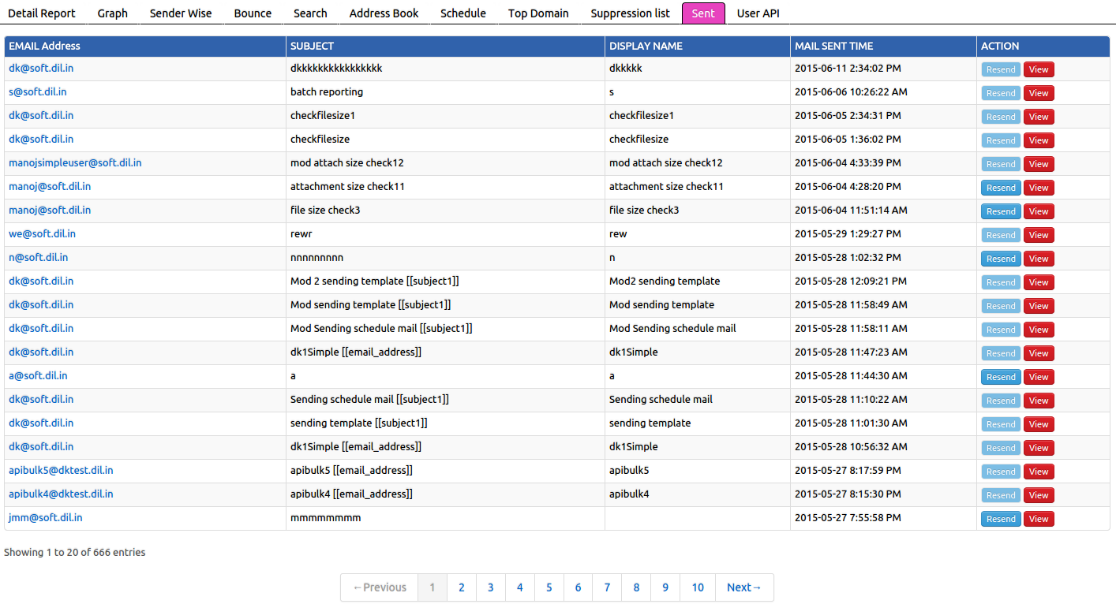

SO user can click over specific one and will have preview of that campaign along with resend option.
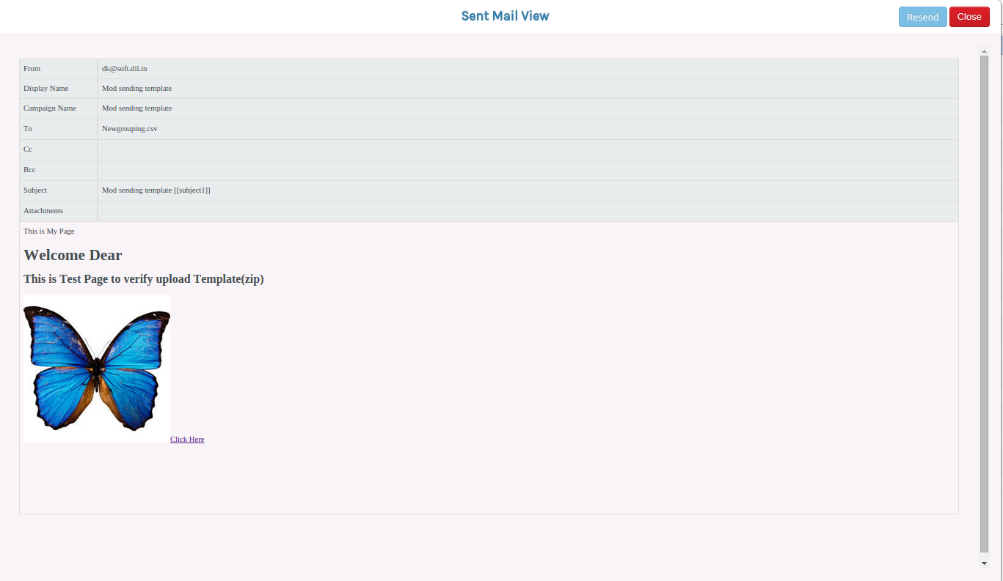
After clicking on “Resend” button, all previously sent details will be get filled in the compose page and user will able to make any modification and Send it.
Note: User can view the sent campaign as per there UserType authorization and can Resend only there own Campaign only.
In TBMS Sent Campaign View/Resend option is available at two more places:

1. At Campaign Detail Reporting
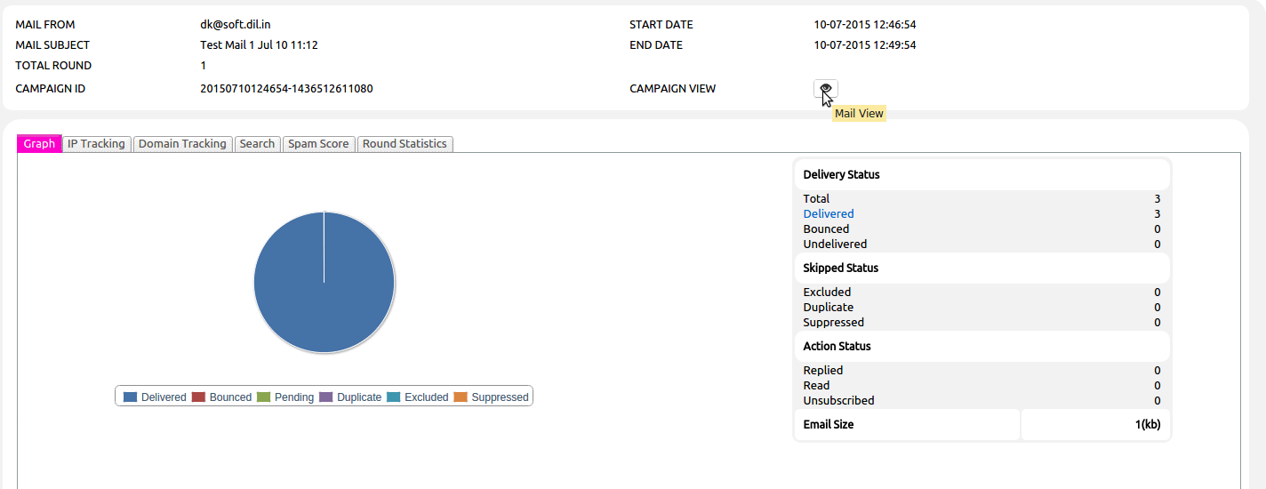

2. At Search Reporting

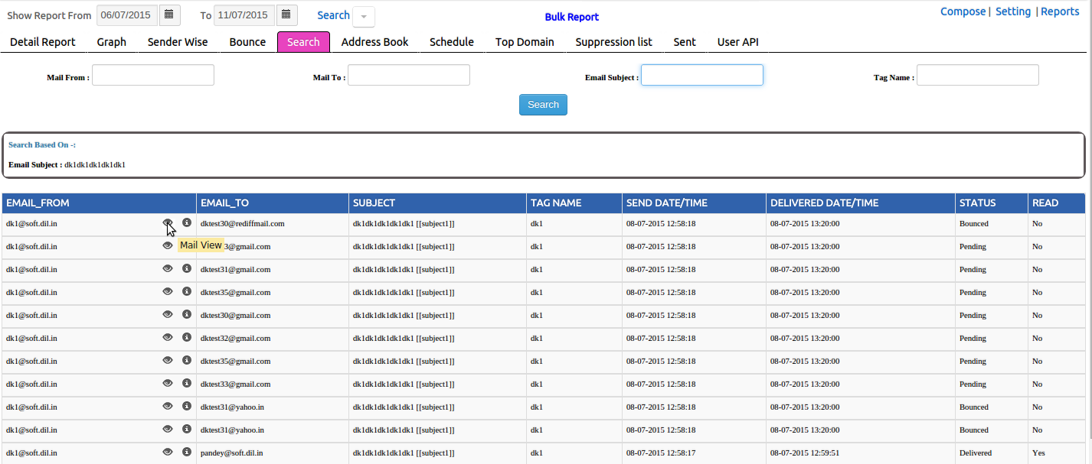

Ipv6 Support:
TBMS allows to use Ipv6 IP-Address To send the Campaign.
TBMS select the Machine Ip version according to the receiver domain.
However TBMS picks the assigned Machine IP as per the round-robin manner for IPv4 Address, still its having some following priority of IPv6 on Ipv4 Addresses:

Test Cases | Sender | Receiver | Result
Case 1 | IPv4 | IPv4 | mail delivered on IPV4 from IPv4
Case 2 | IPv4 | IPv4/Ipv6 | mail delivered on IPV4 from IPv4
Case 3 | IPv4 | IPv6 | Connection can't open
Case 4 | IPv6 | Ipv4 | Connection can't open[ Mx Record Not Found
Case 5 | IPv6 | IPv4/Ipv6 | mail delivered on IPV6 from IPv6
Case 6 | IPv6 | IPv6 | mail delivered on IPV6 from IPv6
Case 7 | IPv4/IPv6 | Ipv6 | mail delivered on IPV6 from IPv6
Case 8 | IPv4/IPv6 | IPv4 | mail delivered on IPv4 from IPv4
Case 9 | IPv4/IPv6 | IPv4/IPv6 | First priority goes to IPv6 so : mail delivered on IPV6 from Ipv6

Domain Based ROUTING (THird Party Api):
- TBMS is having the option to forward the Campaign's Mail to any ThirdParty MailServer so that ThirdParty Mail Server can send the campaign instead of TBMS.
- TBMS is using the HTTP JSON Request to forward the Mail. And providing the API'S so that ThirdParty MailServer can update the real time reporting for relative campaign.

- Server Admin is having the rights to Add/Update the API under Setting section.
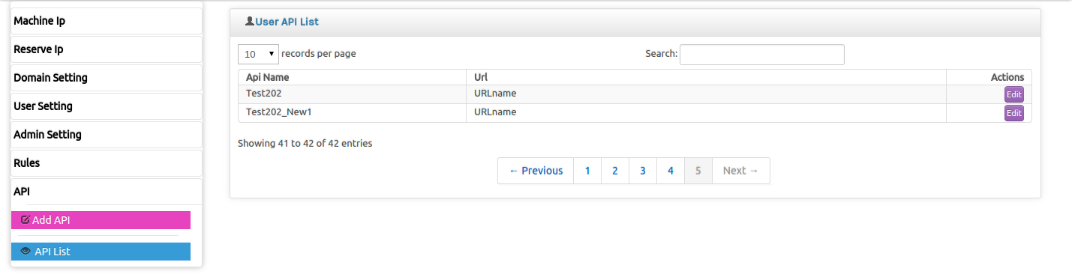

- Server Admin is able to set the API's routing at the three different levels:

(1). Server Level:

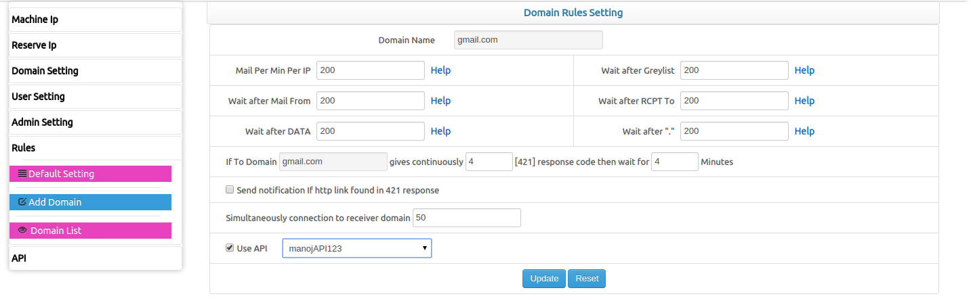

(2) Domain Level
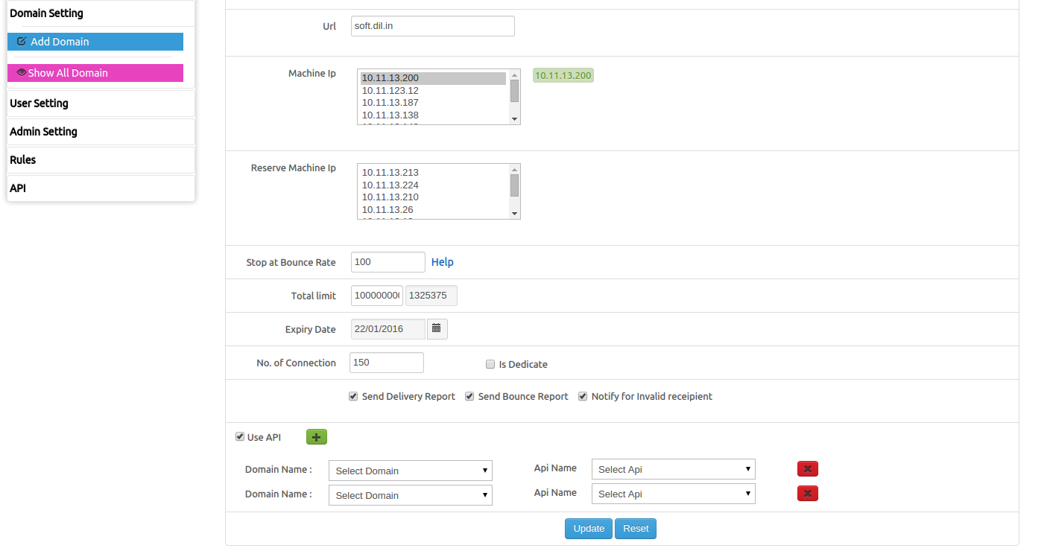

(3) User Level
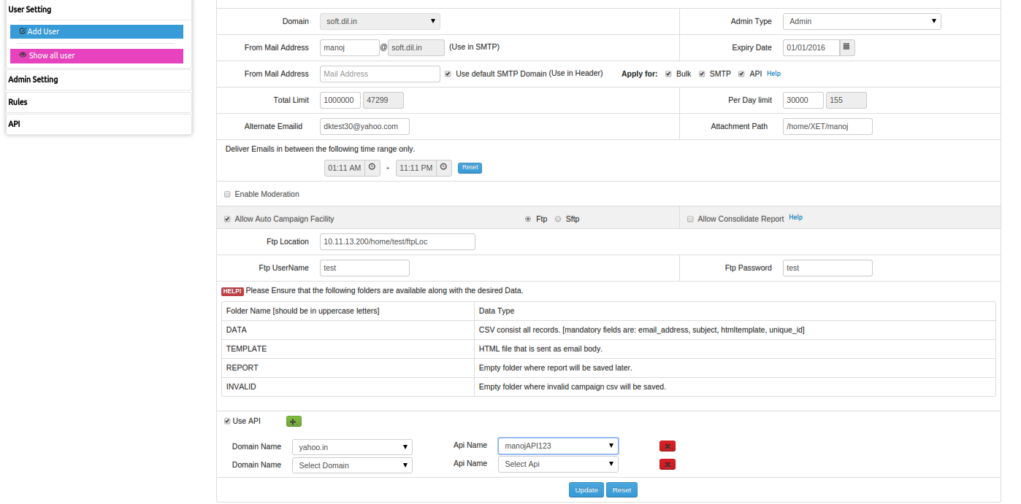

API Reporting:
TBMS is having the interface where Third-Party-Api's is able to submit the real time reports.
In TBMS this report is displayed under the “User API” tab of Bulk Reporting.
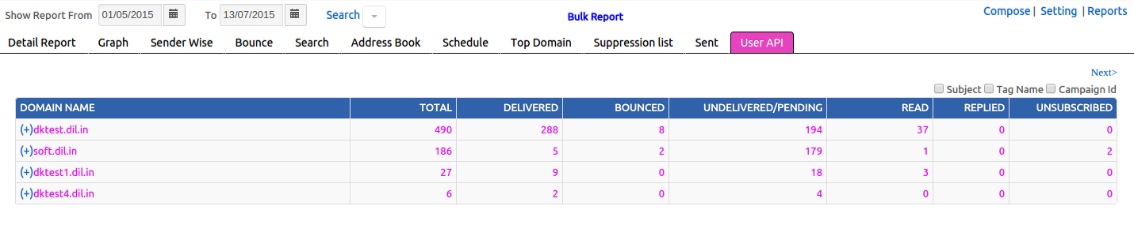

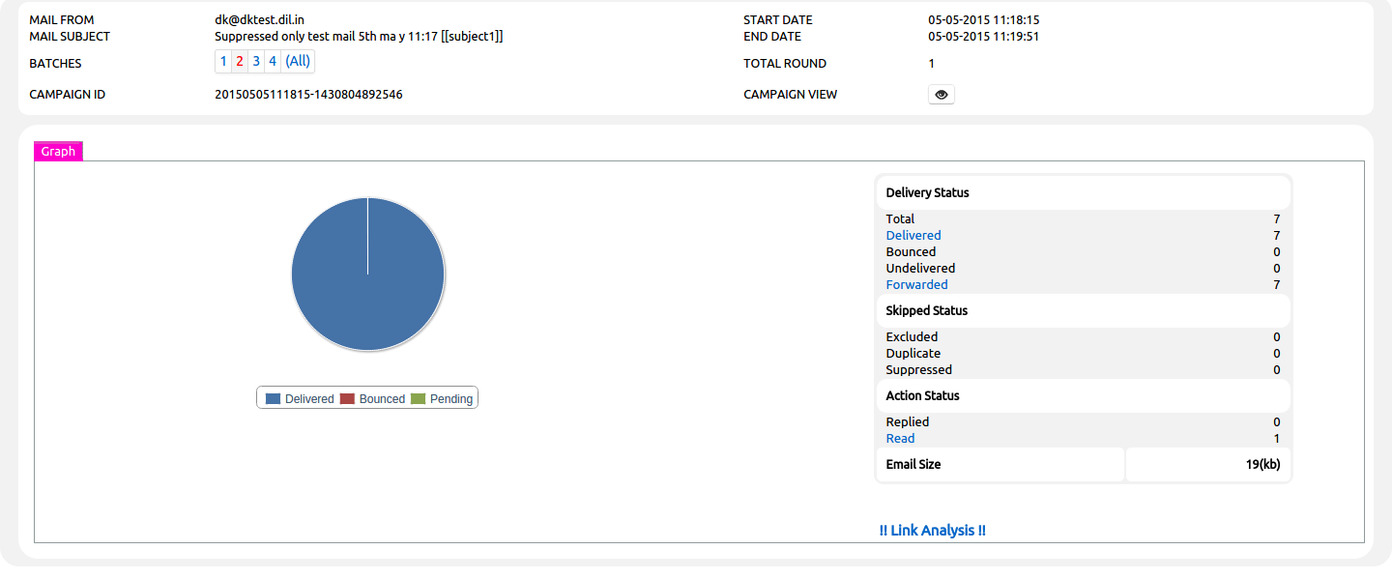

Forwarded:
- In UserAPI reporting one extra status is added “Forwarded”, which is showing the reporting for the Forwarded Mails to Third Party Mail Server.

Exclude Group:
This feature will provide facility to define blacklist mail-ids group within the defined campaign.
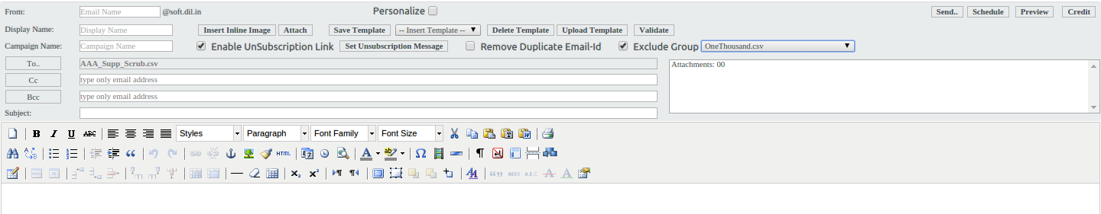
TBMS will display the Group in the compose email page, so it can be excluded.
After exclusion of group from Campaign, this will reflect in the campaign's Detailed reporting : 'excluded'.
By Clicking on Excluded link User is able to view the excluded emailid's and also able to download the list.

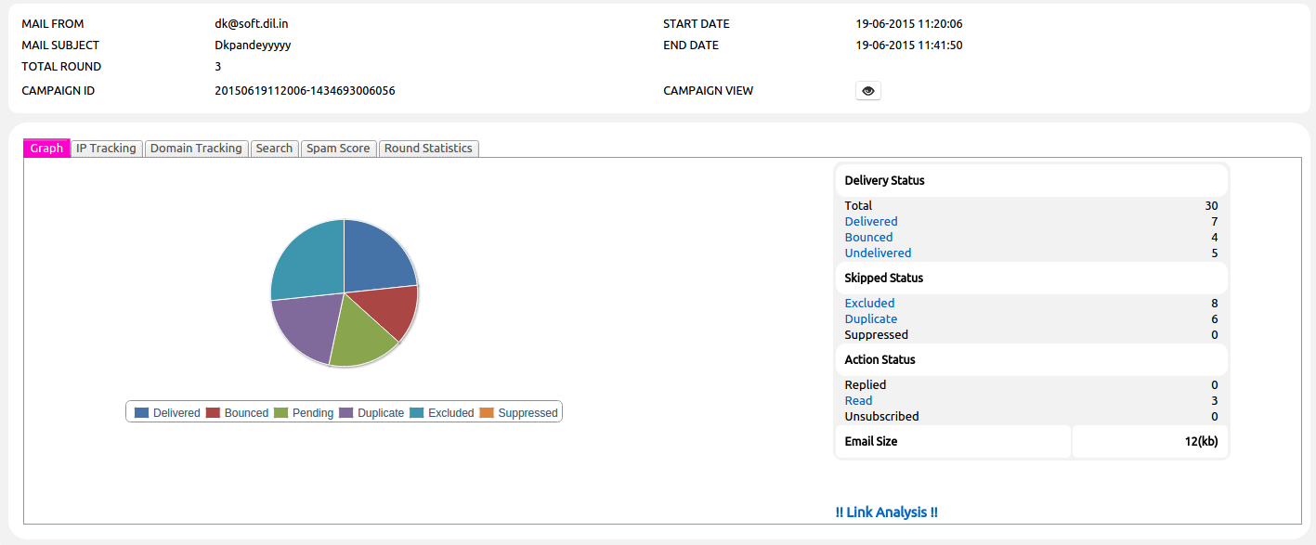

Group Creation under Reporting section:
TBMS is having the ability to create Groups of email-ids based on specific status (Delivered, Bounced, Open, Clicks, Un-subscribed, Suppressed etc) for Selected Campaign's for a selected date duration for Bulk Reporting.
The generated group list contains only unique emailid's, duplicate emailid's will get dropped.
Grouping option is available under the Bulk Report's “Detail Repot” Tab.
By Selecting the Grouping checkBox, one frame will get enabled with various Grouping status.
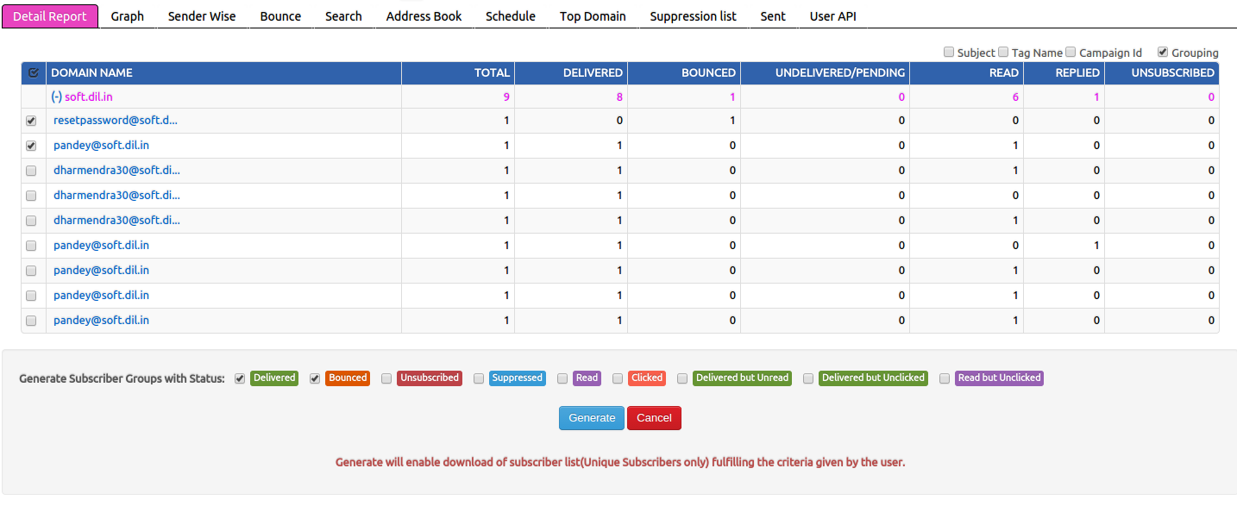

User is able to select the multiple status and multiple campaigns to generate the unique grouping list.
Current available Grouping status:
- Delivered
- Bounced
- Suppressed
- Read
- Clicked
- Delivered but Unread
- Delivered but Unclicked
- Read but Unclicked

Removal of duplicate mails:
Remove Duplicate Email-Id option is allowed the user to remove the Duplicate email's from respective campaigns.
This option is available under the compose page and user can select it while sending the campaign.

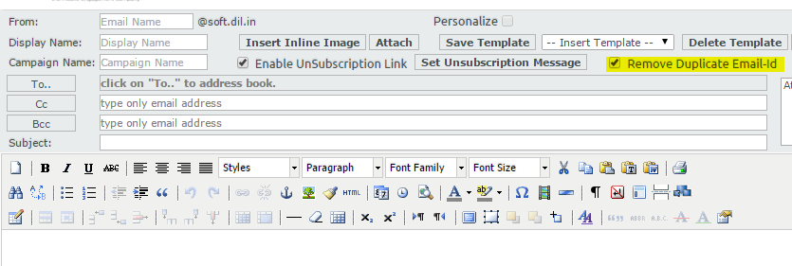

Avoided duplicate Email's will be displayed under the Campaign Detailed report.
By Clicking on the Duplicate Link User will able to view the avoided Email's and able to download the Report as well.

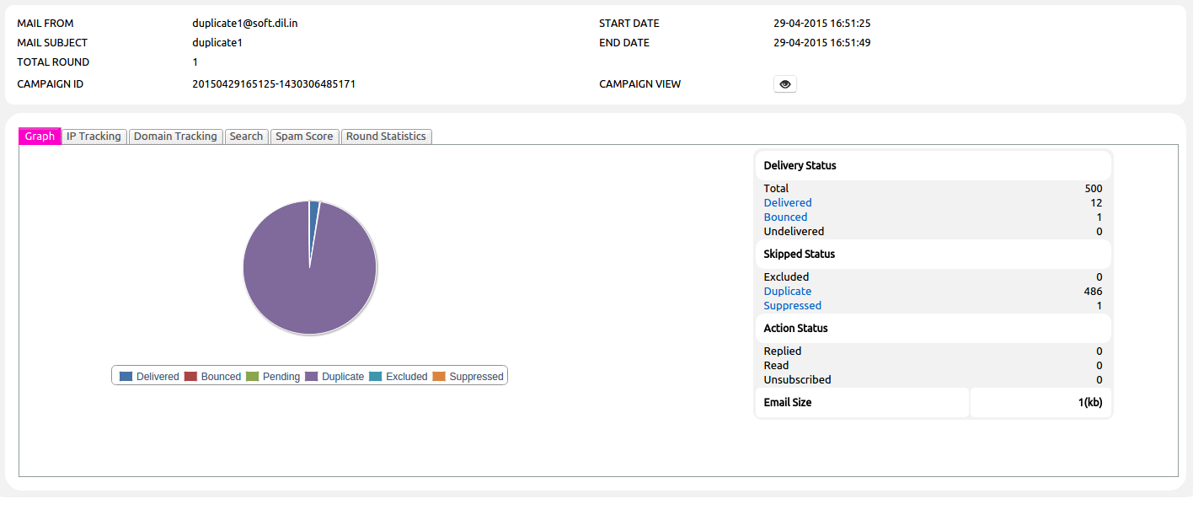

Suppressed Mail reporting:
If a Campaign having the email's which are already exists In the Global Suppression List, Then those emails will get suppressed and Reporting for the suppressed Emails will get displayed in the Campaign's Detail Reporting.
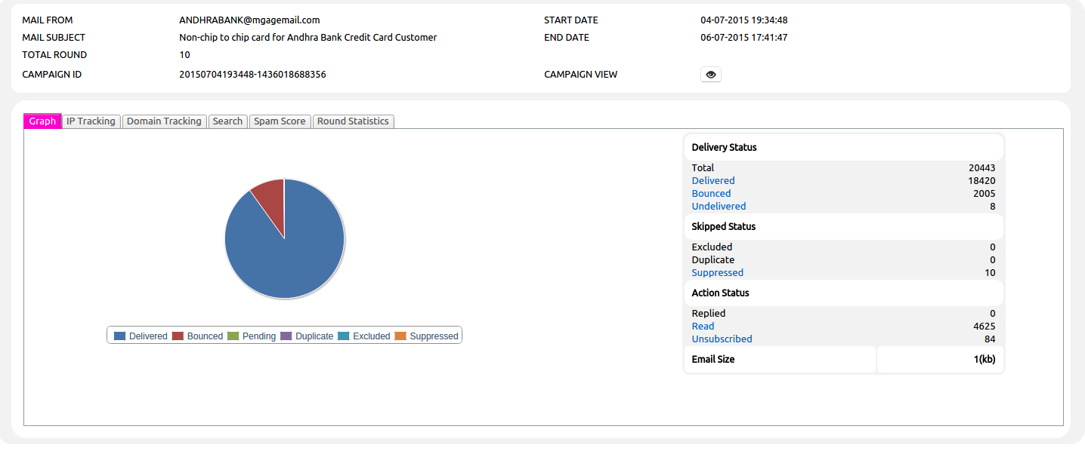

By Clicking on the Suppressed Link User will able to view the suppressed Email's and able to download the Report for the same.

From Name Personalization:
In TBMS Admin/DomainAdmin having the rights to send campaign with customized from name.
But For SimpleUser from name is not customizable.
To overcome from this problem Server Admin having the option to set multiple From Name for the particular Simple User.

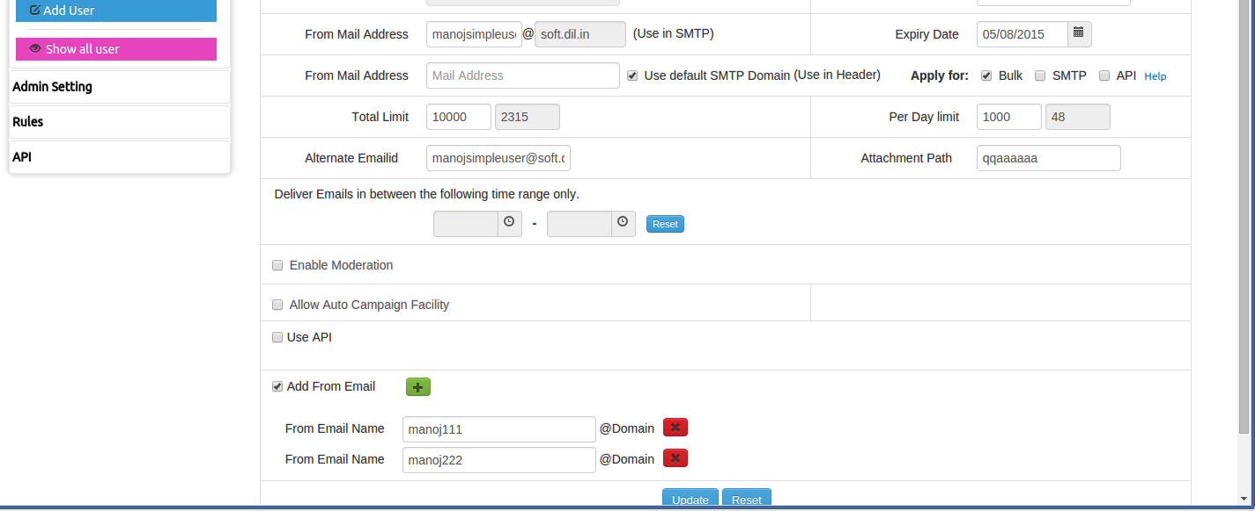

Simple User will able to select the 'from name' from configured 'from name' while sending the campaign.

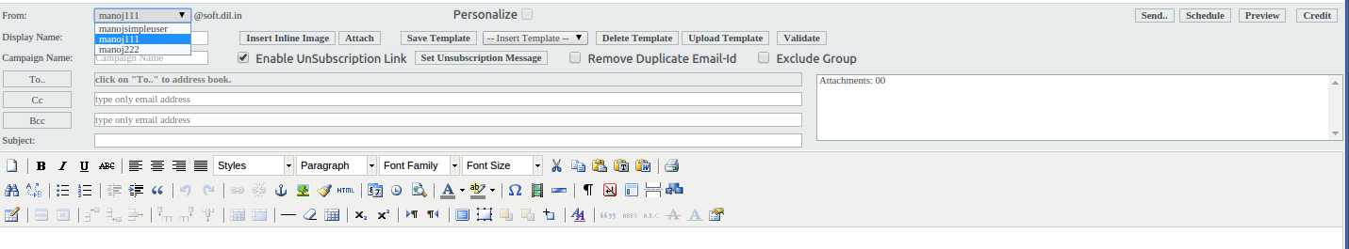

Template Upload option:
TBMS is having the option to upload the HTML template under compose page.
- TBMS allows to upload the single HTML file to get uploaded directly
- If Template having the images than it should be in the zip format.
After uploading the template, template will get saved for future use and get selectd to send campaign.

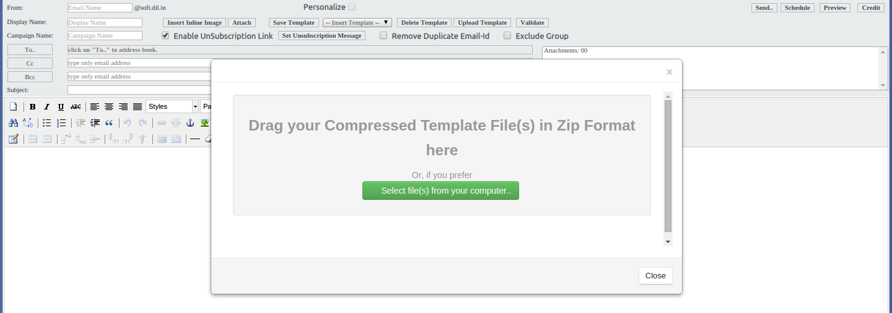

Suppression list scrubbing:
User can scrube the emailid list against the Gloabl Suppression List.
By Selecting the scrubbing list and clicking on the “Delete From Supp” buttion, user can delete the email id's from Global Suppression List matched in the selected list.
One Alert message will display with number of emailid's get deleted.
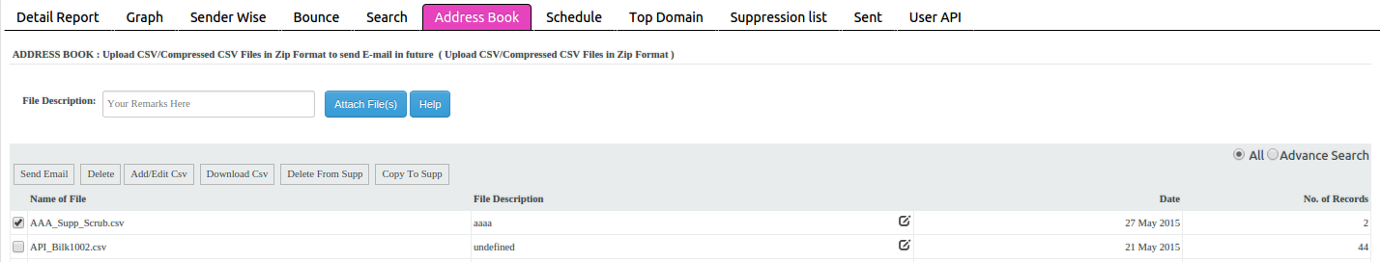

Suppression list Copying:
User can copy the emailid's in the Gloabl Suppression List in Bulk.
By Selecting the list to get copied and clicking on the “Copy To Supp” buttion, user can copy the email id's to Global Suppression List(which are not already exists).
One Alert message will display with number of emailid's get copied.

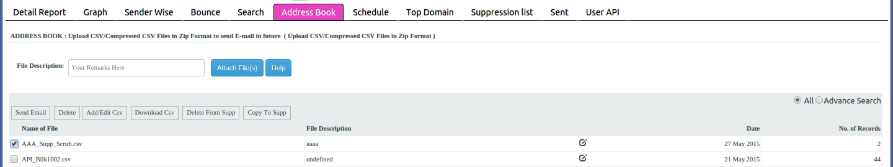

Account lock out Policy:
Server Admin can set the User Account Lock Out Setting for user failure attempts.
In AdminSetting Server Admin can set the 'Number of Login Failed Attempts' and if user exceeds the maximum allowed Failed Attempts than Block the User for Number of Minutes Time duration.
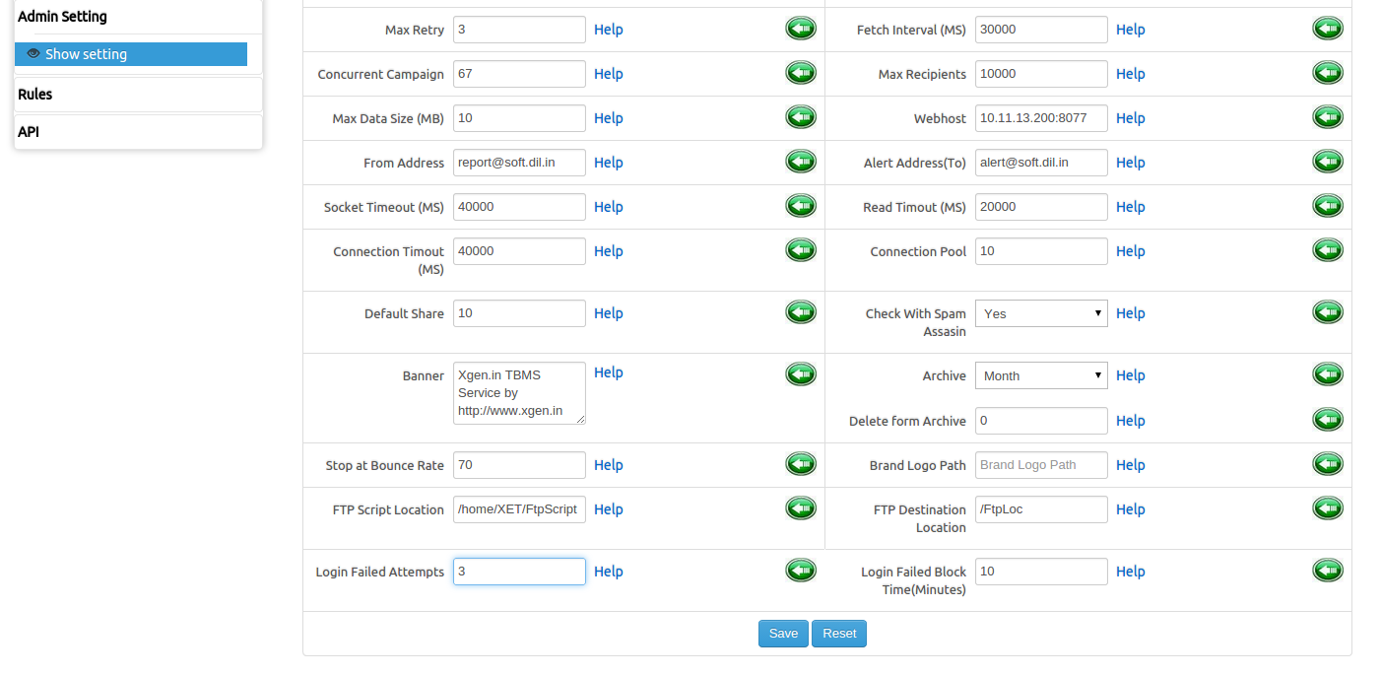
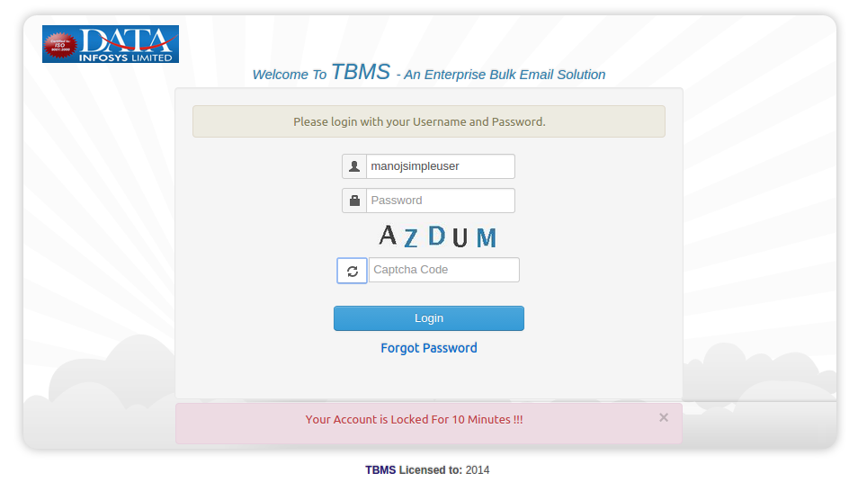

IMPLEMENT CAPTCHA For Login page:
User have to provide the Captcha Details while Login into System.
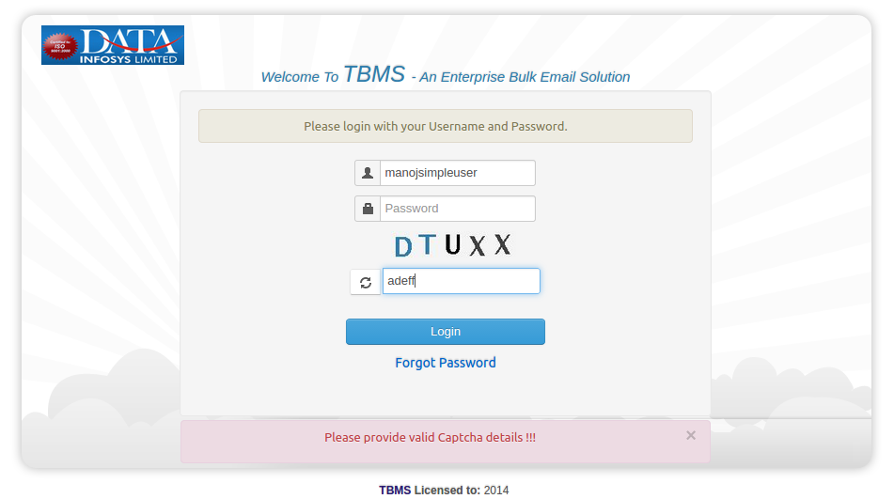

Display user's last login details
TBMS will display the user's last login details on the Dashboard.
TBMS will display:
- Last login IP
- Last Login Date-Time

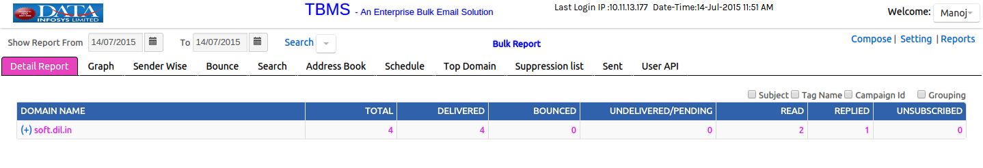

Personalization of Subject lines:
User can send the Campaign with personalized subject line.
Mail Subject line will get displayed as personalized to end receiver.

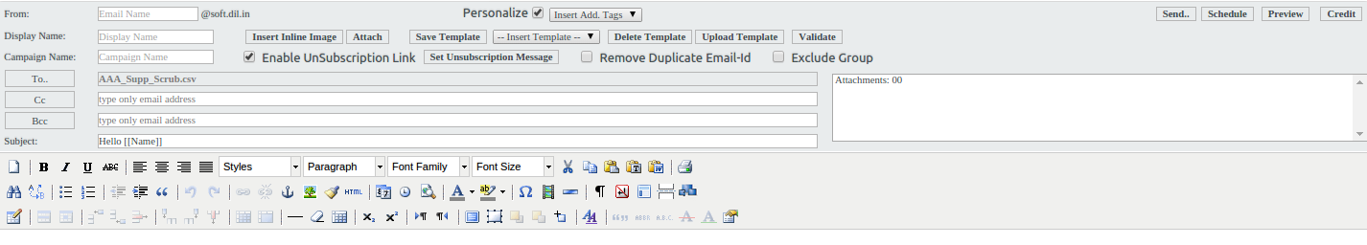

Display campaign Id for campaign:
TBMS will display the unique campaign id for each campaign.
Campaign ID Format is like: YYYYMMDDHHMMSS-XID
This campaign is viewable at two places in TBMS:

1. At Detail Report:
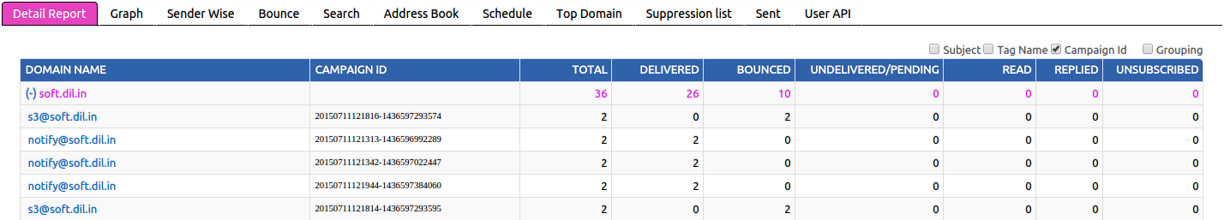

2. At Campaign Detail Report:
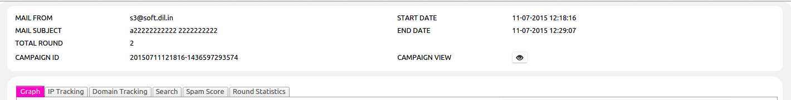

Unsubscribe Link To BE optional:
Now User can set that Campaign should have Unsubscribe link or not.
This option can be set while sending the campaign under Compose page.

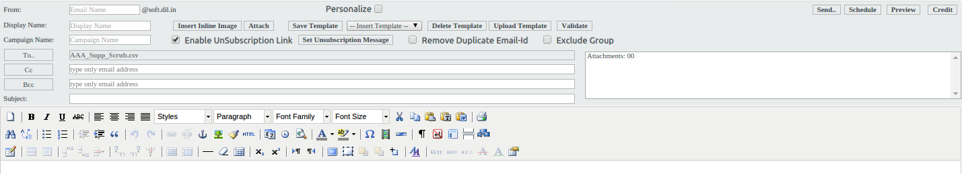

Link Personalization:
TBMS is able to send the personalized link in Campaign.
User can set the personalized parameter or link in the compose body.

List Management (Add/edit in contact list)
We have developed this feature through which user can edit uploaded csv file, delete it, and add new one. Here we are defining process step by step:
- User will select option of Address Book, here they will get a new option of Add/Edit csv. (see screen shot below)

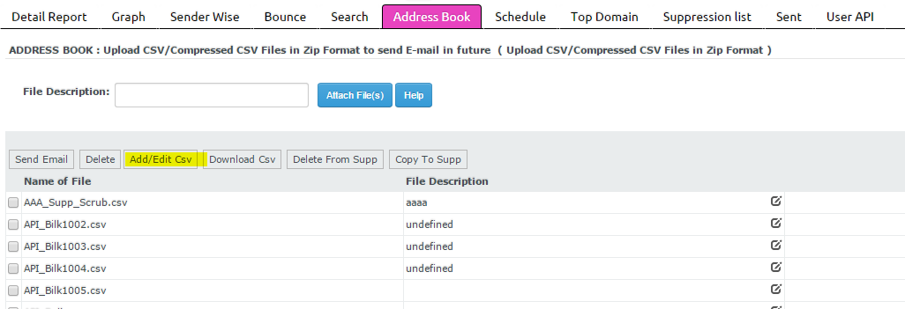
- Now user will select any csv file that they want to edit and will move further for make changes. (See screenshot below)
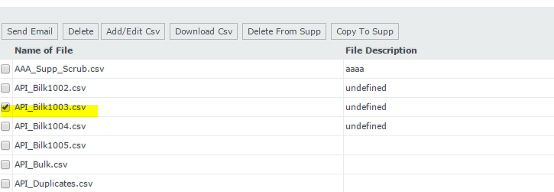
- So once user will select any csv file then will select option of Add/edit csv from top bar, he will get next screen where user can type any name for which they want to edit details, so if that user will be available in list, then it will display, for which user can take any action.
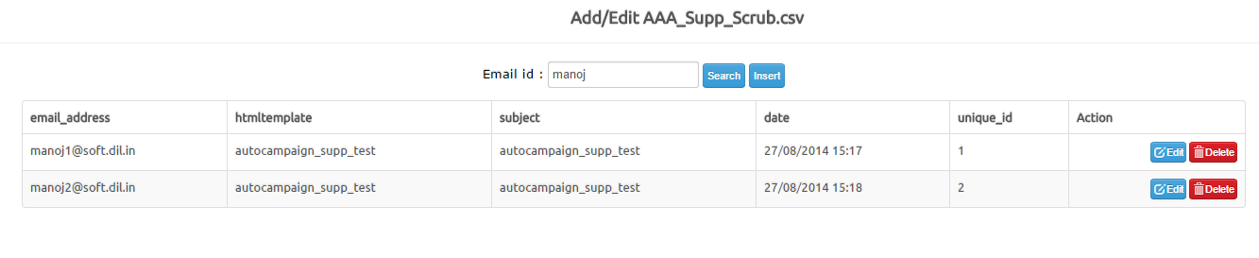
- Now user can edit any detail like name, email address, subject, date, ID & can save it. (Screenshot below)

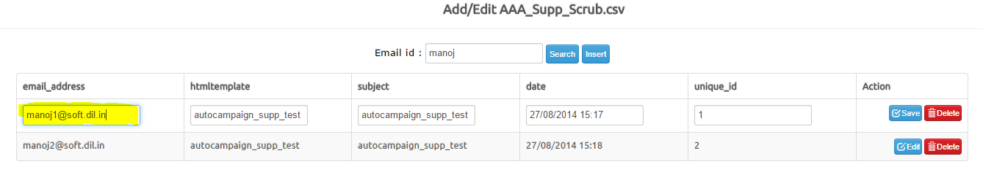
- Once user will edit details, then he will get message of successfully updated details.
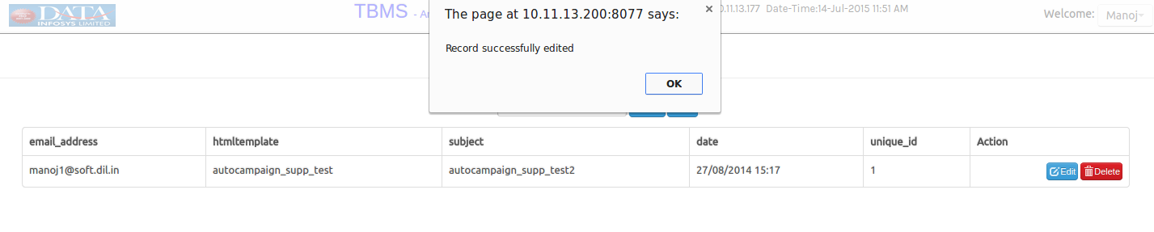

Maker & Checker (Moderation process)
We have developed this feature for verify content of email campaign and assign moderation right to report admin. This will be done by admin. So report admin will get notified if any new email campaign will be sent for which they have assigned as a moderator.
Here these 2 terms will be used:
- Maker: This will be the user who create campaign.
- Checker: This will be the report admin assigned by admin as a moderator for that specific user’s campaign moderation.

This process will work like this:
- Admin will go to the user setting first through setting option. There they will select “Add User”. Here there will be an option to select Enable Moderation. (screen shot)
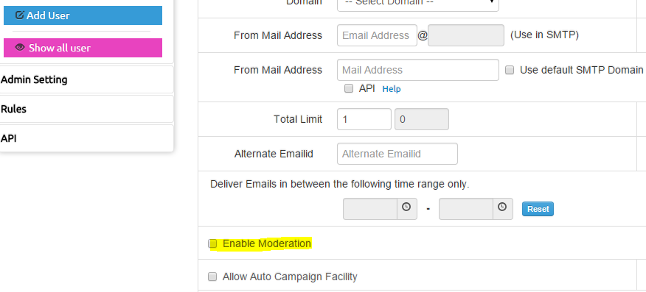

- Once admin will check this option, they will get option to select moderation from the drop down list. These list will be of report admin.
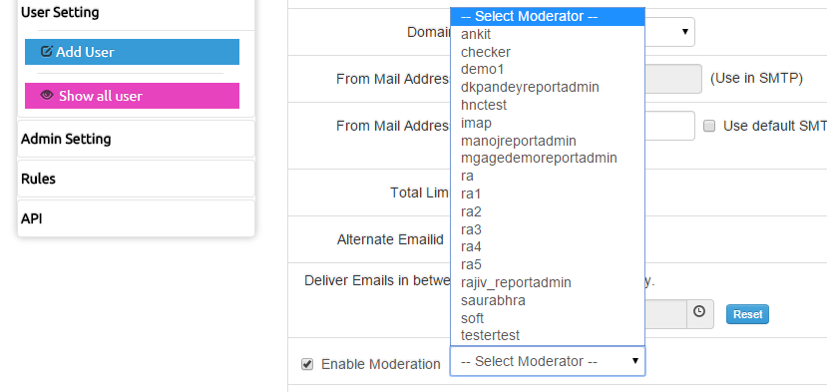

- So admin can set any report admin (checker) as a moderator. Now whenever this user (Maker) will create any email campaign, then this moderator will notified, that you have new campaign for verification. (Screenshot)
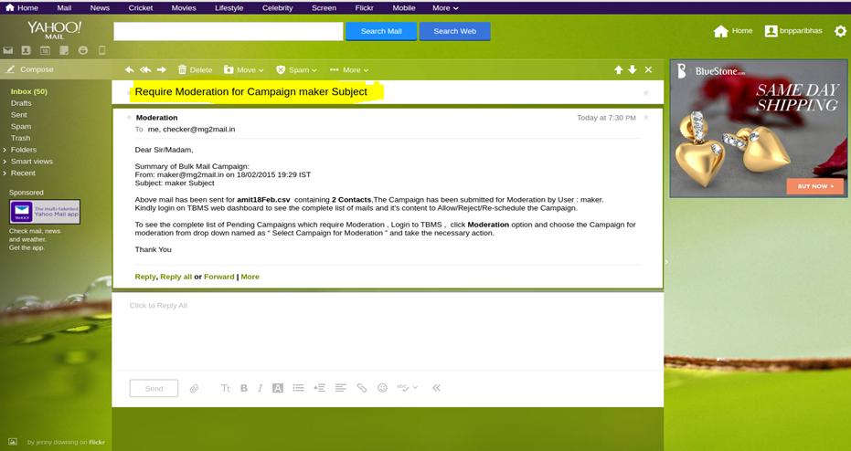
- Now after getting email notification checker will login in the System and select the campaign from Template Drop-Down. All the details will be filled like From, Display Name, Campaign Name, To, CC, BCC, Subject, Attachments, Unsubscribe Option, Duplicate Option, Personalized and content etc.
Checker can update the all details and can Approve/Reject/Reschedule the campaign. But checker cannot update contacts to which maker want to send email. If Checker wants then he can download list contact.
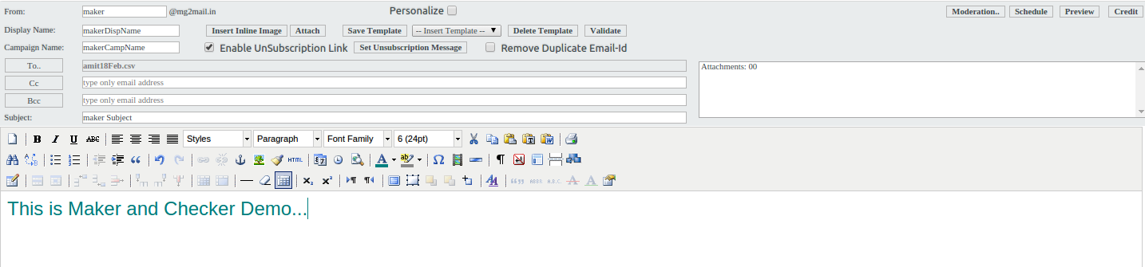
- Now here Checker will have 3 options:
- Accept: If checker finds all the things fine, then he will accept email campaign.
- Reject: If checker finds any inappropriate thing there, then he will have right to reject it. Here they can add message for explain cause of rejection email campaign. SO maker can check this.
- Reschedule: Checker can reschedule email campaign. Checker can change time & date of sending emails, so that email campaign will be reschedule and will automatically send on set time by checker.
So for each action maker will get notification. They will get notifications for these:
- When checker will accept email campaign.
- When checker will reject it along with reason.
- When checker will reschedule email campaign along with their rescheduled time & date.
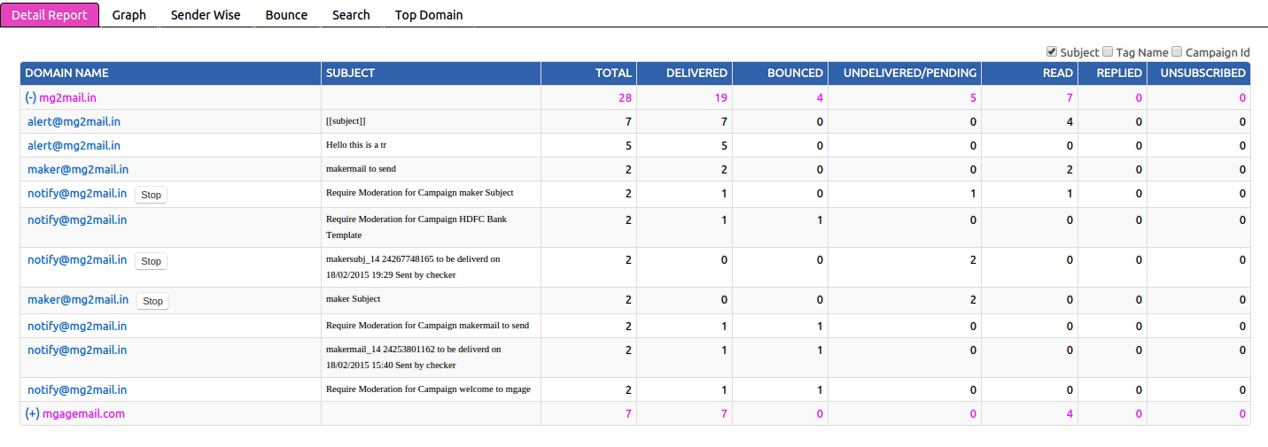
They can view report in form of graph also.
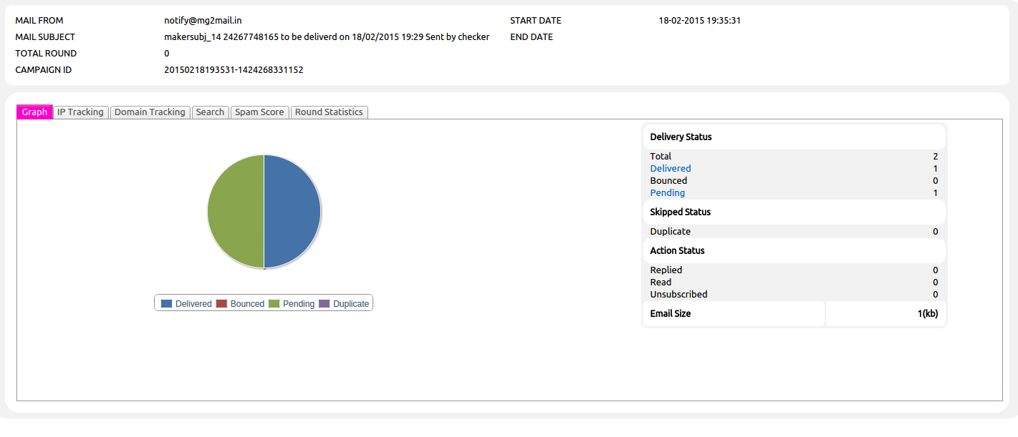

Notification through email:
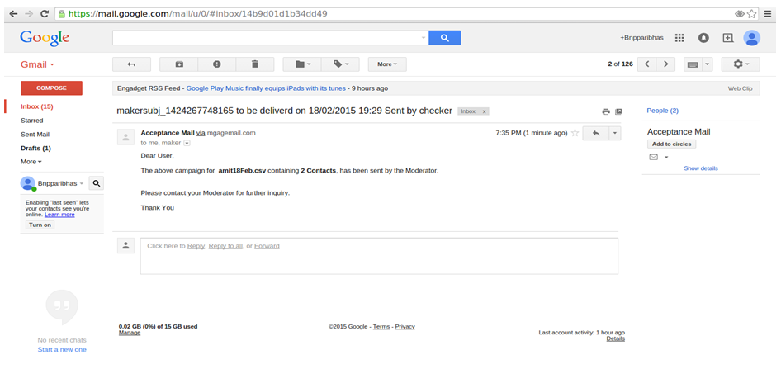
- So once email campaign will send maker can view send emails & checkers can also view preview of email before approval.

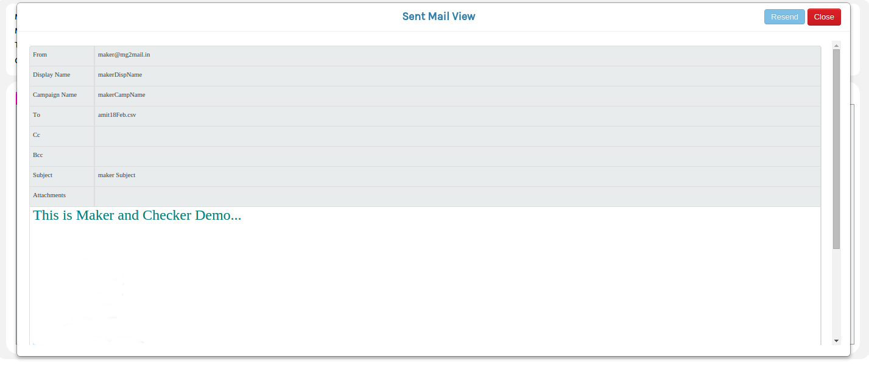
- Maker will get email notification.
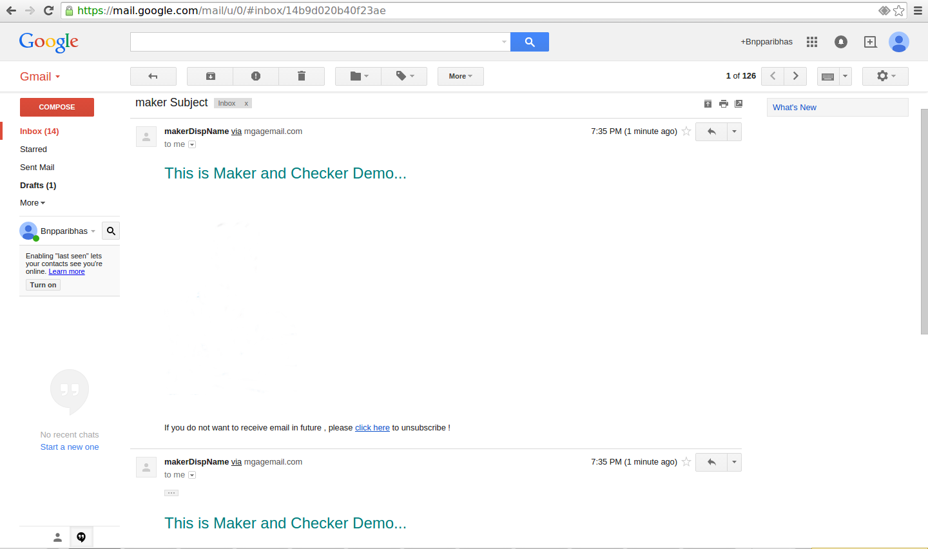

Promotional Campaign via FTP/SFTP
With this option user can set auto sending of campaigns. They will set location of FTP and sFTP details, so system will auto update campaigns and will send them. Process will like this:
- For this admin will go to the setting option. Here they will select user setting, in which they need to select option “Add User”. Once they will select option of Add user, they will have an option of Auto Campaign Facility.
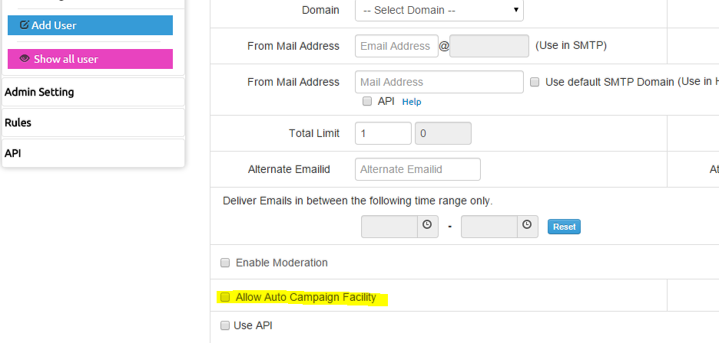
- Once admin will check this option then they will get option of add FTP path, FTP username & password. Before this they need to select one option from FTP/sFTP as per their server. (Screenshot)
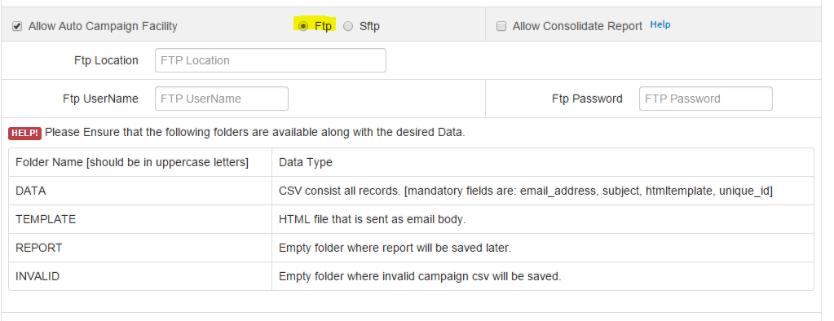
- Now there will be 4 folder details that user must have at their FTP location. These folders will be:
- Data: Here csv will be uploaded along with all the email address details to which user want to send email campaigns.
- Template: Here HTML file will be uploaded that user want to send in email body.
- Report: This will be empty, here dynamic reports will be saved. When any new campaign will send by the TBMS then it will generate a report dynamically including all the details of emails like how many have been delivered, how many bounced, how many pending etc.
- Invalid: This folder will empty and here all those email campaign csv will be saved which will be invalid.
- Now user will add FTP path (from where system should take email campaigns for auto sending), FTP username & FTP password.
- So whenever user will upload new campaign and csv files in folders at the location of FTP, then system will fetch it automatically and will process it.
Note: Here selection of option FTP & SFTP is just as per the server type of user.

Unsubscription through Email:
This functionality will facilitate users to unsubscribe from the emails that they are receiving through email campaign. So user that is creating any email campaign, he will have option to provide unsubscribe feature to his email receivers. Process will be like this:
- User will select compose email option. Here they will get an option “Enable Un subscription Link”
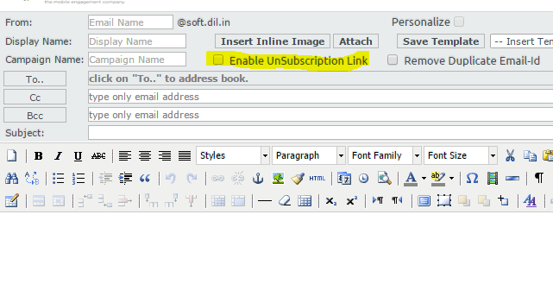
- Now when user will check this option, they will get another tab through which they can set message which will display at the user end.
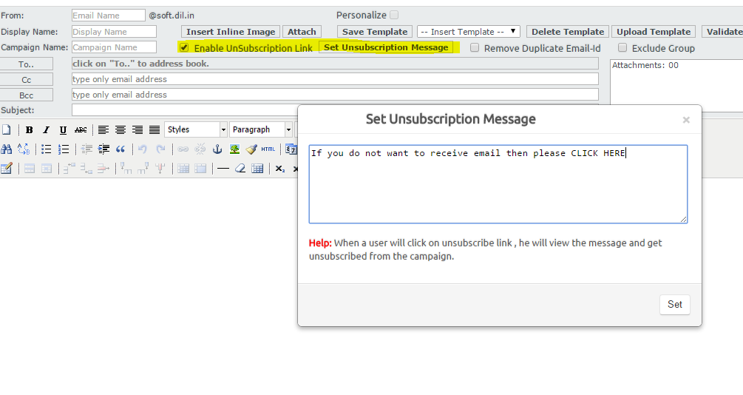
- So once they will set this message, with each email this link will send to receiver. They can click over the link & can unsubscribe their email from this email trail.

Import/export data through csv:
With this feature user can import any csv file or add details and also they can export existing details as well.
Import Data:
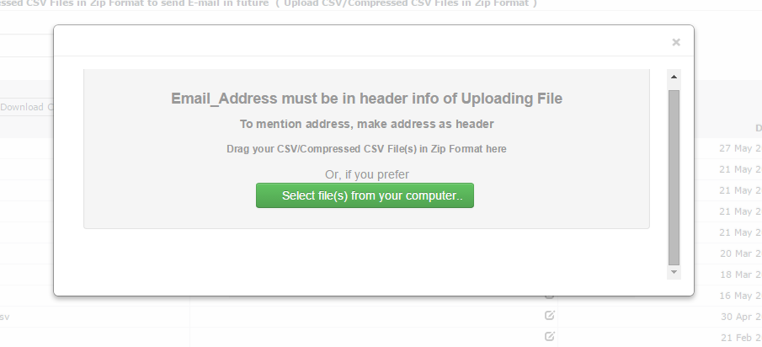

Export Details:
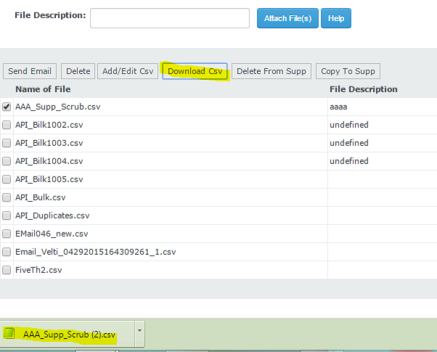

Preview Mail:
User can view preview of their email campaign that they have composed. So that they can check how it will look like at the receiver end.
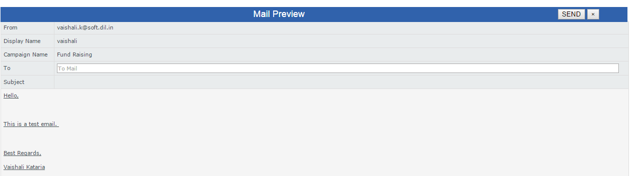

link & image validator:
With this feature, user can validate links included in their message text. They can check link which they have included is valid or not. Process will like this:
- When user will compose any email then they will have an option of “Validate”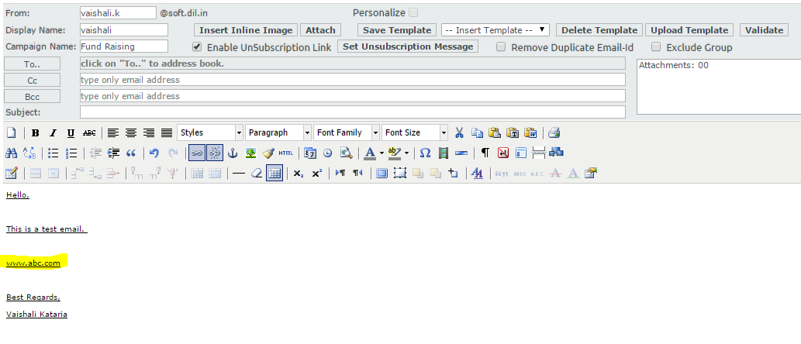

- Now when user will click over the validate option, then a window will open and it will search that this link is actually available or not.

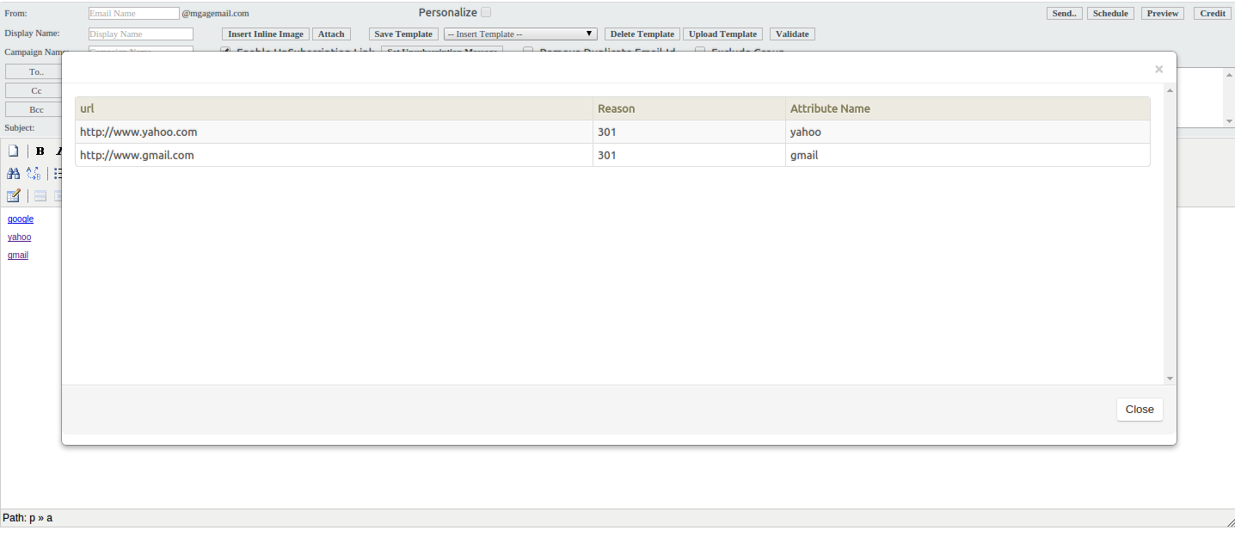

Support of Forget Password
With this feature, user can get support in case when they forget their password. Process will like this:
- When user will hit the url of TBMS, there he will get option to submit their username & password. There they will have a link of forget password as well.
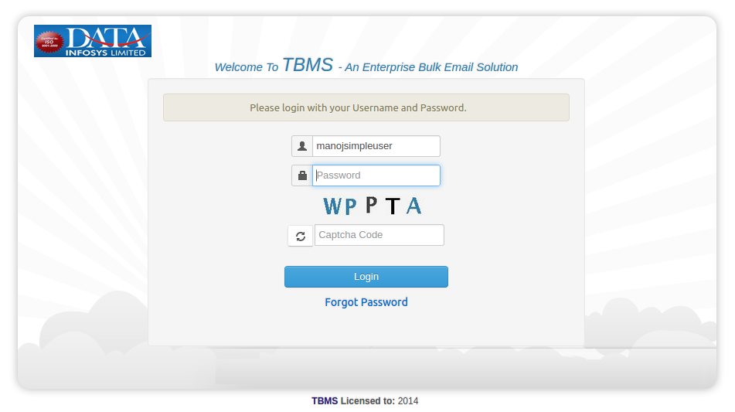

- Now they will click over the forget password. So system check that specified username is available or not in the database. If system do not find that username then they will get a message “username not found” & if that username is available then it will send reset password link over the registered email address.

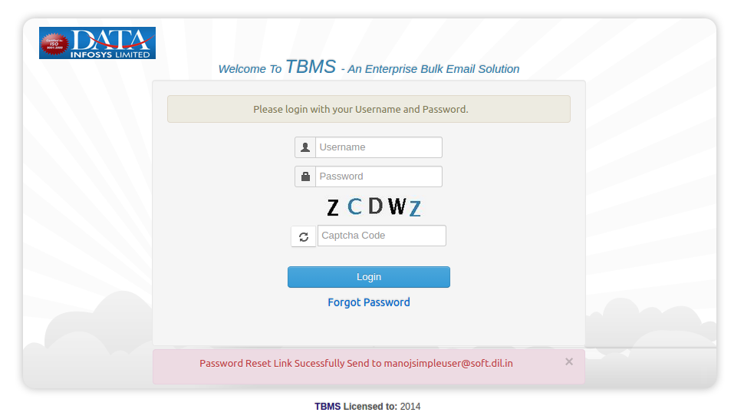

New options in Admin Setting
We have added some new options in admin setting tab. Here is the list.
- Brand Logo Path: Here admin can add path of logo that they want to upload in emails.
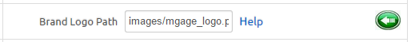
- FTP Destination Location: Default FTP Destination Location where auto campaign data will be stored An absolute path will be generated by appending this location with path ‘/home/XET’
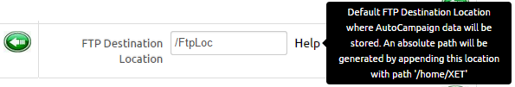

- FTP Script Location: Default FTP Script location to store various FTP script used in auto campaign process.
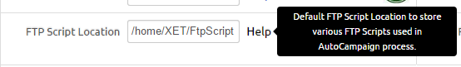

suppression list :
Here those email ID’s will be listed which does not exist or mail should not be delivered over these emails. Suppose for first time when user upload csv file of email address and that list include some invalid emails as well, then automatically these email addresses will be added to suppression list. Also if admin want to add specific email address on which they do not want to deliver any email, then can do that with suppression list. So if any email will be sent through this system, those email ID’s will not receive emails.

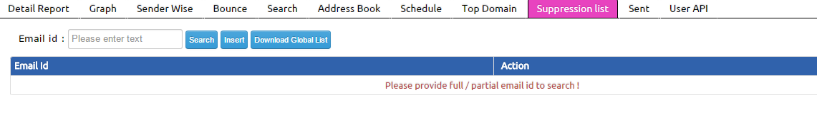

------------------------------------------END OF DOCUMENT------------------------------------------

